Experiment 10
Program :
import cv2
# Step 1: Read the image
image = cv2.imread("image.jpg") # Replace with your image name
if image is None:
print("Error: Image not found!")
exit()
# Step 2: Rotate 90° Clockwise
rotated_image = cv2.rotate(image, cv2.ROTATE_90_CLOCKWISE)
# Step 3: Display images
cv2.imshow("Original Image", image)
cv2.imshow("Rotated Image (90° Clockwise)", rotated_image)
cv2.waitKey(0)
cv2.destroyAllWindows()
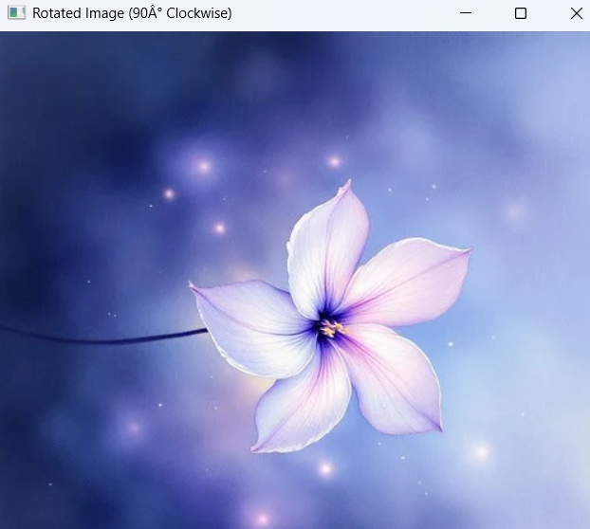
Output:

